


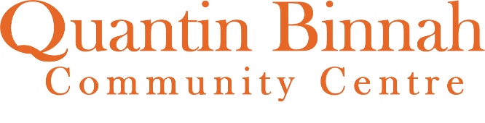



www.qbcc.org.au
61 Thames Blvd, Werribee
Community
Programs
TERM 4 2026

Table of Contents


Table of Contents

Our Vision 3
About Us 4
Room Hire 5
Strategic Planning 5
Creating Villages 6

Café Qb 6
Social Supports 7
Volunteering 7
Community Supports 8-9
Carers Supports 10-11
Expressions of Interest 11
Parenting 12
Special Interest 12
Seniors Activities 13-15
Children’s Activities 16-17
Performing Arts 17
Health and Wellbeing 18 – 19
Education 20
Crafting 21
All Abilities Activities 22 -23
Pop Up Events 24 – 25
2026 Wrap-Up 26
Quantin Binnah Services 27
Contact Information & Safety 28




Our Vision is to Create Connection &
Nurture a Sense of Belonging

At Quantin Binnah, we value community above all else. For us, this means celebrating each individual in our community, nurturing group connections, honouring our similarities and differences and helping each other learn and love each day.
A summary of our charitable purposes are:
To support our community through the provision of benevolent, social, recreational, cultural and educational activities and programs.
To create a welcoming environment to support all those in our community and in particular we strive to be inclusive to our vulnerable participants.
For more information please visit https://www.qbcc.org.au/our-charitable-status-purpose-and-values
Our mission is to provide inclusive education across all ages, focusing on being accessible and responsive to our diverse community needs. We aim to inspire collaboration and connection between community groups and local organisations.
This year, 2026, our theme for programs is “QB Colours Your World”
Please join in the activities for each month and we welcome your ideas for our 2026 themes.

​ Our Key Values are:
Connection Belonging Nurturing



About Us

Qb Community Support

Community Support
At Quantin Binnah we value community. Our Community Support Team strives to invigorate community life and create lifelong connections. We want to connect you with the services and resources that YOU need. We aim to provide high quality community programs that connect people with Quantin Binnah, inspire collaboration and create a sense of belonging to our community.
Our programs are developed to be inclusive across all ages and focus on being accessible and responsive to our diverse community needs. Do not hesitate to contact us regarding a particular service you're in need of and we'll be happy to help
For bookings and information
Unless individually or otherwise stated please contact the Community Support Team, Penny & Emma on community@qbcc.org.au or 9742 5040 to discuss activities further and to register your interest.
Please attempt to register for all activities listed in the booklet this will help us to meet the resourcing and catering needs of all sessions.
Contact Us
Email: community@qbcc.org.au
Phone: 9742 5040
Website: www.qbcc.org.au
Facebook: www.facebook.com/quantinbinnah




Room Hire
Room Hire
At Quantin Binnah we have a variety of multipurpose spaces for hire.
Our Expressions of Interest for regular hirers for 2027 is open now and will close Friday 6th November. Applications forms are available from our website or by contacting community@qbcc.org.au
Rooms are available for hire outside of Quantin Binnah’s regular centre operating hours i.e. evenings and weekends. We also have some space available during centre hours.
For further details including the hirer’s information booklet, hire rates and virtual tours of our spaces please look at https://www.qbcc.org.au/hire-facilities-1
Please note hire rates are subject to change from the 1^{st of} July each year.


Strategic Planning
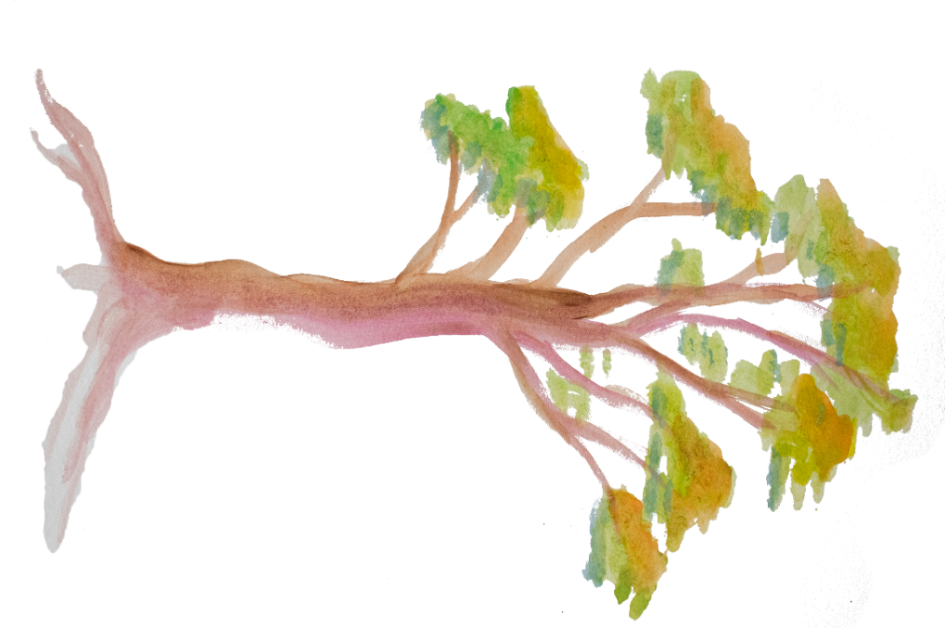
Quantin Binnah is embarking on the development of our next Strategic Plan. As a valuable member of the QB community, we are seeking your participation in the process. The next Strategic Plan will provide the direction for Services at Quantin Binnah for the next 5 years. As part of this planning process we will be researching community needs, reviewing demographic data and seeking your ideas and feedback about potential directions for services.

We have our survey ready for you to complete, and we do hope as many of you as possible will provide a response about potential directions for our services.
You will find a link to the survey on our website here: https://www.qbcc.org.au/strategicplanning
The timeline for the development of the plan will be approximately 6 – 10 months and once completed, it will be available on the website.
We thank you in advance of your participation in supporting the creation of our new plan.
Please contact QB if you would like to participate - 9742 5040 or admin@qbcc.org.au



Quantin Binnah is proud to be partnering with
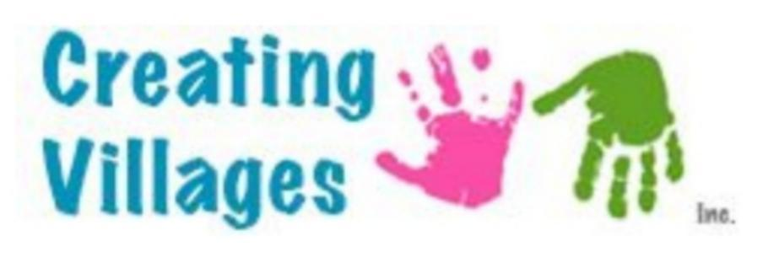
Creating Villages is a not-for-profit company creating inclusive community spaces and places to advance health outcomes and reduce social isolation by providing affordable opportunities for creativity, skill development and connections.

Creating Villages support adults with disabilities
to operate the café; support our participants with disabilities to learn new skills and be included in their community.
Café QB operating hours
Mondays, Tuesdays and Wednesdays
8.30am to 4.30pm
Thursday 8.30am to 2.00pm
Closed on public and school holidays.
Hours are subject to change at short notice due to volunteer availability.

Please support the team working in the café; they are working pro bono.
By purchasing something yummy to eat and/or drink you are supporting Creating Villages with this social initiative venture. All money made from purchases will be re-invested into produce and supplies.

​ Please consider Café QB as your café of choice or for catering your morning tea or lunch function in 2026.

Look out for weekly specials and events
EFTPOS facilities are available.

For more information check out facebook.com/craftandcaffeine OR qbcc.org.au/cafeqb



Social Supports

Chatty Café
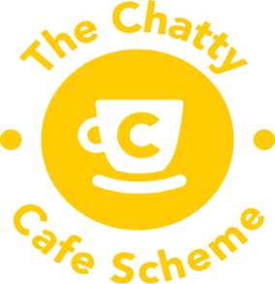
The Chatty Cafe Scheme aims to get people chatting to build and encourage social connections within the local community, and to help reduce social isolation. Join others at the chatty table in Café QB to “chat”.
Day: Every Monday during school term, except public holidays

Time: 9.30am to 11.30am

Crafting

Cost: Gold coin donation for hot drinks for those sitting at the chatty table.
Other items available at menu prices
Please note gold coin drinks are ONLY available during the Chatty Café session

Puppet Pals with JoJo
Josie, Rosie and the gang will be hanging out in Café QB. Come and be entertained by our puppet friends, come for a chat & cuddle. Believe it or not, puppets can help us to develop and foster social connections and emotional awareness.
Day: Every Tuesday (except first Tuesday of the month) during school term
Time: 11.00am

Crafting

Cost: FREE


Volunteers
Quantin Binnah is looking for volunteers!
Volunteering is a fun and easy way to explore and share your interests and passions. As a volunteer you can make a significant contribution to various services delivered at Quantin Binnah - YOU can make a difference.
Support QB and Café QB by volunteering in any of the below roles:

- Activity set-up, management and facilitation.
- Café support
- Garden and grounds maintenance
- Intergenerational activities
- Board member
- Other Opportunities not listed
You can register your interest to volunteer directly through our website www.qbcc.org.au/volunteer or by volunteers@qbcc.org.au



Community Supports

Food Relief Supports
We understand the financial challenges that everyone is experiencing due to the increasing cost of living and are making attempts to support those in need with food support. People accessing these services are required to live within the Wyndham LGA and are required to complete a form for statistical and funding purposes on their first visit.
Please be mindful of others, follow limit quantities and take only what you need.
QB take no responsibility for stock supplied through this service.
Thanks to the generosity of Foodbank & The Melbourne Locals these services are provided to the community
Help us to help you, and to assist with sustaining the service, we ask that you make a

voluntary gold coin donation to access our Food Relief supports.

Fresh Food Collection
Our “QB Food for You & Me” program has fresh food available for collection fortnightly.
Day: Fortnightly Wednesday recommencing 14th October
Time: 9.00am until supplies are exhausted (usually by 10.30am, if not earlier)

Please note food varies fortnightly dependant on availability but usually includes vegetables, fruit, milk and bread.
Food Pantry
A pantry is located in Café Qb with set opening hours during school terms, except public holidays, recommencing from Monday 5th October.
Monday 11.30am to 1.30pm
Tuesday 9.30am to 11.30am
Wednesday 1.30pm to 3.30pm
Please note food is basic pantry staples and varies dependant on availability but usually includes canned goods, rice, pasta, UHT milk, breakfast cereal.
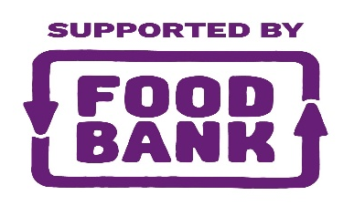



Breakfast Club
Before dropping the kid’s off at kindergarten or school come in for some brekky together to help you fuel your day. Don’t have any children, that’s fine you’re welcome too. No questions asked. Breakfast includes cereal, toast, yoghurt & fruit.

Day: Every Monday, Tuesday and Wednesday except public and school holidays
Time: 8.30am to 9.00am
Cost: Gold coin donation appreciated but not expected.
VEC Community Information Session
The session will be delivered by a Senior Election Official from the Victorian Electoral Commission (VEC). Sessions are interactive and tailored to our community audience, and typically run for 30 minutes.
The session will cover:
- Why voting matters.
- What support is available to help the community vote with confidence.

- How they can participate in the 2026 state election.
- What’s new at the 2026 state election.
Day: Wednesday 28th October
Time: 9.30am

Crafting

For resourcing purposes please RSVP by Monday 26th October to community2@qbcc.org.au
Community Connector

Wyndham City’s Community Connectors assist all residents in our community to access the services they need and empower them to make informed decisions. A Community Connector can assist with, however not limited to:

- Information, links and/or referrals about/to services and emergency relief, such as food relief and material aid; Mental health support and counselling; Family violence support; Family, youth and social support; homelessness and emergency accommodation; financial support; homecare, personal care, etc.
- accessing and navigating State and Commonwealth funded programs
- information about council services.

Community Connector is a FREE Service available at Quantin Binnah Community Centre fortnightly on Wednesday’s recommencing 14th October

from 9.00am to 12 noon Contact 1300 023 411 if you would like to speak with a Community Connector or to book a face-to-face appointment.



Carers Supports

Quantin Binnah is an official Carer Friendly Place as recognised by Carers Victoria
Walks for Carers
Our carers get together once a month, go for a walk, and chat about all things related and unrelated to being a carer. Continue your chat in Café QB with a free morning tea.
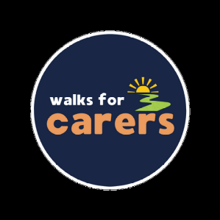
Our priority is improved carer wellbeing through social connection and informal peer support. Please note no one is expected to be a marathon walker, we are more a leisurely stroll group.
Day: Please contact QB to confirm dates

Time: 9.30am
Cost: FREE
Connecting Wyndham Carers
This group is a welcoming space led by its members, sharing information, connecting with local services and supports, and meeting new people. The group focuses on activities that support wellbeing, with suggestions and ideas coming directly from you.
Carers are those who currently support a family member or friend who has a disability, developmental delay, medical condition, mental illness or are frail due to age. Being a carer looks different for many of us, it is something you do for a spouse,
partner, parent, child, sibling, grandchild, friend, or neighbour.
We are committed to making our sessions accessible and inclusive, contact us for accessibility requirements.
Day: Monday 26th October, 30th November* and 14th December*
Time: 10.00am

Crafting


Cost: FREE
*Monday 30th November – Excursion offsite
*Monday 14th December – End of Year Break Up @ 12.00pm & Carer’s own expense
For more information and/or to register your interest please contact
Emma – community2@qbcc.org.au or 9742 5040.



Carers Week 11th – 17th October 2026
The theme for 2026 is "Care for a Carer: Making Carers Visible"
We aim to recognise, celebrate, and raise awareness of the more than 3 million Australians providing unpaid care to a family member or friend.
Do you “see” a carer in your life? We encourage individuals, communities, and workplaces to support and care for the carers in their lives
Carers Week shines a light on the profound impact carers have on our communities.
#Careforacarer #CarersVictoria #NCW26
Sit Back, Slow Down and Feast – A Care for a Carer Lunch

Crafting

We’re inviting Carers living within Wyndham to join our Connecting Wyndham Carers group to celebrate & acknowledge the wonderful work that carers do.
“This One Is For You: A Celebration of Our Carers”.
Let QB make you as a carer visibile and take some time out for yourself and enjoy a delicious catered lunch.
Day: Monday 12th October
Time: 12.00pm to 2.00pm

Crafting

Cost: FREE
Bookings Essential - Please RSVP with any dietary requirements by Wednesday 7th October to community2@qbcc.org.au
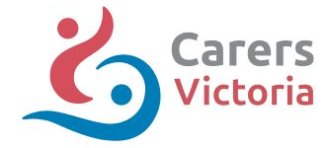



Expressions of Interest

We are seeking expressions of interest from anyone wishing to facilitate and/or participate in
- Parents groups and/or workshops

- Book Club

- Walking Group/ Pram Walking Group
- Seniors Groups
- Cultural Groups
- Specialty Groups and Classes

Parenting

Crafting 

Parent Pathways
Every parent’s journey is different, which is why Parent Pathways and The Salvation Army Employment Plus focus on support that’s made just for you. Whether you need help exploring career options, bridging skill gaps, or finding training that fits your family, our mentors are here to guide you. We’ll work with you to create a plan that suits your circumstances and needs.

The Parent Pathways team at The Salvation Army Employment Plus can help with:
• Language and literacy programs
• Career guidance
• Childcare placement assistance
• Driving lessons
• Financial support for training
No pressure. No judgement. Just support that fits into your life.

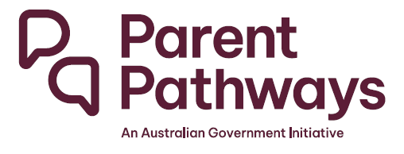
Visit their website www.employmentplus.com.au or call them on 136 123 to find out your eligibility

Special Interest
Knitting Group
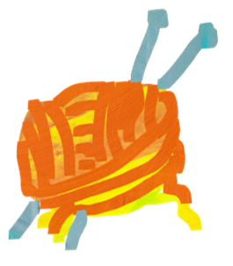
Do you like knitting? Would you like to join a group of like-minded ladies and chat whilst clicking away. Work on your own items or knit items to donate.
Day: Thursday’s
Time: 1.00pm to 3.00pm

Cost: FREE BYO knitting projects and patterns to share




Senior’s Activities

Crafting

Seniors Festival 2026 - Connect. Create. Celebrate.
The theme of the 2026 Victorian Seniors Festival is 'Connect. Create. Celebrate. ' which aims to encourage older Victorians to stay curious and connected by exploring new activities, meeting new people, and changing how we think of ageing.

Join us at Quantin Binnah to CONNECT with others and services in our community, CREATE new memories and friendships and something special and CELEBRATE with old and new friends and enjoy all our fun, inspiring and engaging activities.
We can’t wait to see you during Seniors Month and every other time.

Lunch with the Bunch
We’re inviting our Senior Friends to come & join us at Café QB for a delicious lunch & great company.
Date: Monday’s 5th October &/or 9th November &/or 7th December
Time: 12.00pm to 2.00pm
Cost: $15 per person includes 1 Barista made hot drink, sweet & savoury treats. Additional drinks are available to purchase from Café QB.
BOOKINGS ESSENTIAL Please RSVP by Thursday prior to event with any dietary requirements.

Discover Mercy Health – Ageing Well Services
Information Session & Morning Tea
At Mercy Health, we believe every person deserves to live with dignity, respect and compassion at every stage of life. As a provider of health and aged care services, we are committed to delivering exceptional care that nurtures body, mind and spirit- whether in our hospitals, aged care homes, clinics or on the comfort of your own home.

Join us to learn more about
- Navigating My Aged Care and accessing government funded homecare
- Accessing residential aged care (respite and permanent)
Date: Tuesday 13th October
Time: 10.00am
Cost: FREE
BOOKINGS ESSENTIAL Please RSVP by Thursday 8th October with any dietary requirements.

Seniors Tech Support Workshop
Need some help to trouble shoot minor problems you are having with your smart phone or device?

Come along to this basic workshop with a self-taught Gen Z and learn the tips & tricks you need to navigate the tech world we live in now.
Robert will let you know if you require professional assistance
Date: Thursday 15th October
Time: 10.00am
Cost: FREE
Do you have anything specific you would like to learn about? Let us know beforehand so we can include it in the session

Please RSVP by Monday 12th October for resourcing purposes
Seniors Craft & High Tea
Enjoy a delicious high tea with us.
Make your own masterpiece to take home or gift to someone
Date: Monday 19th October
Time: 10.30am
Cost: $10* per person includes craft, morning tea and barista made hot drink
BOOKINGS ESSENTIAL Please RSVP by Thursday 8th October with any dietary requirements.
Steps to Accessing Aged Care - Your questions answered
Estia Health Information Session
Estia Health is proud to present this free information session to help you understand and access the support you need.
- Navigating the aged care system from home care, respite to residential care (for those requiring more support)
- Accessing government funding.
- The benefits of respite care for you and your carer
- Demystifying living in Aged Care, what to expect when you come in
- Costs for entering Residential Aged Care both Respite and Permanent Care.

Date: Tuesday 20th October
Time: 10.00am
Cost: FREE

BOOKINGS ESSENTIAL Please RSVP by Thursday 15th October with any dietary
requirements.


Bingo Moves for Seniors
Bingo Moves is best described as a fun, interactive exercise program – combining gentle movement & stretches helping you to unwind and move safely whilst playing a game of BINGO. This special Seniors Session will be slower paced with lots of seated movements. A great exercise for body and mind
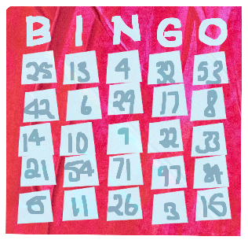
Prizes and a whole lot of fun await you.
Date: Wednesday 21st October
Time: 11.30am
Cost: FREE
Please RSVP for resourcing purposes by Tuesday 20th October


Morning Melodies with Trish Simpson
Join us for a fun morning of Golden Oldies with music and singing by musician Trish Simpson including a lovely morning tea.
Date: Thursday 22nd October
Time: 10.00am
Cost: $5* per person includes entertainment, morning tea & barista made hot drink
BOOKINGS ESSENTIAL Please RSVP by Thursday prior to event with any dietary requirements.

Hearing Australia
Take the first step to rediscovering the sounds you love. Join us for a FREE 15-minute hearing check and take the first step to better hearing today!
(Other services may attract charges/fees or may be subsidised for those eligible under the Australian Government Hearing Services Program, to which conditions apply)

Date: Thursday 29th October
Time: 10.00am to 2.00pm
Cost: FREE
BOOKINGS ESSENTIAL = Appointments are available in 15-minute increments. Pick a time that works for you.

*These activities are generously subsidised by the Wyndham City Council.


Please refer to our other categories throughout the booklet inviting our Seniors to join other community members in activities to meet their own needs. These categories include but are not limited to
Health & Wellbeing, Special Interest, Social Supports, Volunteering and Pop-Up Events


Children’s Activities
Playgroup

Playgroup is an exciting way for young families to be involved with the local community centre and share time with families that have children of a similar age. Children get to participate in experiences that they can share with their peers, siblings, parents and carers. ​Our weekly sessions provide opportunities for families to meet in an inclusive, welcoming, friendly, safe environment. We provide a Leader to plan and set up the activities each week.
Day: Every Thursday during school term
Time: 10.00am to 12.00pm
Cost: $70 per term plus a one-off enrolment fee of $30 per family.
Apply via the QBCC website https://www.qbcc.org.au/playgroup

Story Time with JoJo
Once upon a time at Café Qb we met a fairy godmother, a unicorn, and other magical beings. Bring the kids along to a fun, inclusive, interactive, and educational story time. Books are read by QB’s very own Creative Artist and Author in Residence JoJo.
When you wish upon a star anything can happen…

Day: Tuesday’s during school term (except 1st Tuesday of the month)
Term 4 dates - 13th, 20th & 27th October, 10^{th,} 17th & 24th November and 8th December*
Time: 10.00am.
Cost: FREE
Parents/carers are required to stay in attendance.
Your caffeine needs can be met in Café Qb.

OOey gOOey Messy Play

Come along and get messy with different sensory craft, for any age.
Children to wear clothes that can get messy
Due to popular demand we’re running 2 sessions in Term 4.
Day: POP-UP activity – Wednesday 7th October & 2nd December
Time: Drop in anytime between 10.00am to 11.00am
Cost: FREE
Parents are to remain onsite and provide supervision during session.

Children’s Week Celebrations 25th October to 1st November
The national theme for Children's Week 2026 is ""Children have the right to use their own language, celebrate their culture and practise their religion" “which is based on Article 30 of the United Nations Convention on the Rights of the Child.
Join us for our FREE activities. Don’t forget to RSVP to help us with our planning and preparation.
Teddy Bear’s Picnic @ Storytime with JoJo

Celebrate Children’s Week with JoJo & Friends. Come along with your favourite cuddly friend and receive a little present to take home.
Day: Tuesday 27th October
Time: 10.00am to 11.00am.

Kiddie Crafternoon

Inviting children of all ages for an afternoon of free craft. Make your own little Fairy Garden or giant colouring in posters and enjoy some snacks celebrating children’s week
Parents/carers to provide support and supervise.
Day: Tuesday 20th October
Time: 2.30pm to 4.00pm.




Performing Arts
PerformX Academy

PerformX Academy is a vibrant performing arts program for children and teens aged 5–15, designed to build confidence, creativity and courage through drama, singing are welcome to join. Classes are delivered in a safe, supportive, and inclusive environment by passionate industry mentors.
Day: Saturday’s during school term
Time: 11.45am to 3.15pm
Cost: $14 per hour
For more information, please contact PerformX Academy – 9967 8721 or email admin@performxacademy.com.au or check out www.performxacademy.com.au

Health & Wellbeing

Movement, Mindfulness and Meditation (MMM)
Join our new mindfulness and mental wellbeing program at Quantin Binnah exploring and supporting meditation and self-expression which will be open to all ages, stages and all abilities.
MMM explores how to express oneself freely and authentically in a safe environment without fear of judgment or criticism – we all know the saying “Dance like no-one is watching”, come along and join in this fortnightly wellness session. The group will have a different mindfulness and/or wellbeing exercise each fortnight.
Each session will begin with a 10-minute meditation and end with a gratitude exercise – “what are you thankful for today?”
Day: Wednesday’s 7th & 21st October 4th & 18th November and 2nd December

Time: 1.00pm to 3.00pm
Cost: Gold coin donation appreciated
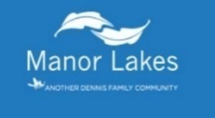

YOGA with Ni De Space – your space to simply be you
Yoga & Mindfulness | Find your Calm in the Chaos
Your weekly ritual for renewal. Find your breath. Move with ease
Relaxation Yoga allows you to unwind from the day and reset for the week ahead. This calming evening class focuses on slow movement, deep stretches, and guided relaxation to help you release tension and improve sleep.

Rest & Reset
Day: Monday’s
Time: 7.30pm to 8.30pm
First Class FREE for every new student
Cost: Casual $18 | 5 classes for $75 | 10 classes for $140
BYO: Yoga mat and water bottle
For any question and to register your interest please contact Steph at stakholisticwellness@gmail.com


Bingo Moves Community
Bingo Moves is best described as a fun, interactive exercise program – combining gentle movement & stretches helping you to unwind and move safely.
Join us for an active version of BINGO where you’re invited to participate in gentle MOVEment to a song. Prizes and a whole lot of fun await you.
Day: Wednesday’s fortnightly, recommencing 7th October
Term 4 dates – 7th & 21st October, 4th & 18th November and 2nd December
Time: 10.00am
Cost: Gold coin donation welcome but not expected

Wonder Women
Would you like some time for yourself? Would you like to spend some time with other women and just “hang out” with no expectations placed on you? Come and join us and spoil yourself.
Day: Every Thursday during school term
Time: 9.30am to 11.00am

Cost: Gold coin donation appreciated
New members welcome.

Stretch
Stretch Class: Move Freely, Feel Better

You don’t need any gym experience to join this class! If touching your toes feels like a challenge, sitting on the floor seems impossible, or you’ve grown used to living with aches, pains, and stiffness—this class is for you. Target all your joints and muscles. Over time, you’ll notice your body moving in ways it hasn’t before, improving flexibility, mobility, and overall comfort.
Day: Every Thursday during school term
Time: 1.00pm
Cost: Gold coin donation appreciated
BYO Comfortable clothing, shoes & drink bottle.




Education
ACFE learning opportunities
The primary purpose of pre-accredited education and training is to provide opportunities for adult learners in Victoria to gain the educational capacity and core skills they need for study, work and life.
Courses are FREE to eligible students. Students must be 17+ and not enrolled at school AND be an Australian citizen, holder of an Australian Permanent Visa, a New Zealand citizen or Asylum Seekers holding a valid Visa.

Individual learning assessments will be completed with each student prior to commencing course. This is an ACFE funding requirement.
Students will receive a Certificate of Participation on completion of the course.
Barista Essentials

Want to know how to make the perfect coffee? Learn the skills of a Barista and increase your employment opportunities. Or you may just love coffee and want to add to your knowledge and personal skill set.
Last opportunity for 2026!
Course dates: Friday’s 23rd AND 30th October
Time: 9.30am to 2.30pm

Cost: FREE
ACFE courses in 2027
- Digital Skills
- Mind @ Work
- English for Beginners
- Barista Essentials
We’re excited to be offering some new & engaging learning opportunities, as well as our ever-popular courses in 2026.
All courses are designed to introduce key skills to students who are looking to at further education opportunities or want to gain employment or are working towards gaining employment.
Keep an eye out for course details and dates.
EOI are being accepted now.
Crafting
Cosy Kennel Crafts – new program

A community group that meets to create handmade items such as blankets, toys and comfort items for local animal shelters.
Supplies included but donations of resources are appreciated.
Day: Monday’s during term excluding Public Holidays
Time: 2.00pm
Cost: FREE

Craft & High Tea
Enjoy a delicious high tea with us and make a special themed craft item to take home or gift to someone. Our Term 4 Themes will be
October – Halloween
November – Tea Party
December - Christmas
Day: Monday 19th October &/or 16th November &/or 14th December
Time: 10.30am
Cost: $18 per person includes morning tea & craft project
BOOKINGS ESSENTIAL Please advise of dietary requirements when registering
Leftovers & Lunch
Feel like getting crafty with others in a social setting?

Come along and complete some of our most recent craft projects for $10 each.
Or bring along your own craft project.
Day: Wednesday 21st October & 18th November
Time: 12.00 noon
Cost: $10.00 per person for craft project supplied by Café QB.
BYO your lunch or buy something from Café QB
Australian Crochet Community
All welcome to drop in, crochet and chat. Bring your own crochet or craft project with supplies along to Café Qb and join in with others.
Day: Saturday 17th October, 21st November & 12th December

Time: 10.00am to 2.00pm

Crafting


Café Qb will be open to nourish you as you craft.
. All Abilities Activities
CraftABILITY

Adults with Disabilities (& their carers) are invited to join us to complete a different activity each week. Come along & be creative, be social and maybe enjoy something to eat from the Café menu.
Activities may vary from craft including baking, games and other activities dependant on participants requests.
Day: Every Tuesday during school term
Time: 10.30am to 12.30pm
Cost: $10 per person for weekly project or
$15 including a delicious morning tea & project
$20 including a delicious lunch & project
BOOKINGS ESSENTIAL. Please email creatingvillages@gmail.com for more information, to make a booking and advise of dietary requirements.


Cook & Connect
All Abilities Cooking & Social Group – New Program
Cook Up a Storm: Build Skills, Make Friends
Join our friendly, hands-on cooking program for people of all abilities. Learn practical kitchen skills and make simple, tasty treats. It is a great way to build confidence, make new friends and have fun

Learn some basic cooking, baking and healthy eating skills during this self-directed session, it is a self-paced session with a recipe to follow.
If you require assistance, please bring your own support person.
Day: Fortnightly Wednesday’s during school term resuming 14th October
Term 4 dates – 14th & 28th October, 11th & 25th November and 9th December
Time: 1.00pm
Cost: $15 per person
BOOKINGS ESSENTIAL
BYO container to take your goodies home. Support people are to remain onsite and provide support during session. Numbers are capped per session and weekly registrations are required. Please contact us for more information, to register and advise of dietary requirements.

Capacity Building at Café Qb
Would you like to learn new skills, gain experience in a café and meet new people?
Do you have core supports in your NDIS plan?
Supports provided at NDIS unit costs.

Participants are required to be self or plan managed. Have a chat to our Café Qb team.

GLOW – Inclusive Disco
Our Term 4 GLOW falls on Friday the 13th!!!
Some may say this day is a little spooky, but did you know that November 13th is World Kindness Day?
Be kind and spread the word, bring your friends. We want to see YOU on the dancefloor!!

Adults with Disabilities (& their carers if required) are invited to spend the night with friends, dance and hang out in a safe environment.
Quiet zone available for those who need a break.
This is an 18+ alcohol-free event.
Day: Friday 13th November
Time: 6.30pm to 9.30pm
Café QB will be open from 6.30pm for yummy treats
DJ Pistol Pete will start pumping the tunes from 7.00pm
Cost: $15 includes entry, snack & a drink.
Carers free entry & drink.




Not just a Community Centre,

but a centre for the Community



Pop Up Events
Kid’s Clothes Swap
Start getting organised and sorting out all your children’s old, good quality items. The swap also includes toys and books. Organise your items into sizes and please make sure they’re clean and in good condition.
If you don’t have anything to swap or donate you are still welcome to attend. Clothes will also be available to those who have nothing to swap. In the lead up to Christmas the toys and books might be a good present option

Day: Monday 9th, Tuesday 10th & Wednesday 11th November
Time: 9.30am to 1.30pm.
Please note we are unable to accept any donations until the days of the kids swap.
We are unable to store anything afterwards and donations will not be accepted after 11.00am on the final day.
Quantin Binnah’s 34th Annual General Meeting
The Board of Governance of Quantin Binnah Community Centre warmly invite you to attend our Annual General Meeting.

We will be celebrating the year through our curated slide show and themed song to launch our 2027 Theme and to complement our Annual Report and 2027Calendar.
Day: Wednesday 28th October
Time: 7.00pm (including a light supper at the conclusion of the AGM)
Cost: FREE
Please RSVP (including any dietary requirements) by Wednesday 14th October to
admin@qbcc.org.au

Morning Melodies

Enjoy a fun morning of music and singing including a lovely freshly made morning tea with Barista hot drink.
Come dressed to impress for our themed Morning Melodies –
October theme is Golden Oldies
December theme is Christmas Celebrations
Day: Thursday 22nd October and/or Thursday 10th December
Time: 10.00am arrival & morning tea. Show begins at 10.30am.
Cost: $12.00 per person includes morning tea and entertainment
BOOKINGS ESSENTIAL Please RSVP by Tuesday prior to event with any dietary requirements
Halloween – all week @ Café QB

Come along to Café QB dressed in your “spooky” costume to receive a Trick or Treat!
We’ll have some themed craft activities for you to complete too.
Day: Monday 26th October to Thursday 29th October
Time: 9.00am to 4.00pm
Cost: FREE
Special spooky drinks and snacks available to purchase from the café.

End of Year Food Drive
As the end of year approaches and many of us start planning celebrations and feasts, there are those in our community wondering how they’ll feed their families when services close over the Festive break.
Unfortunately, we are experiencing a hunger crisis with 3.4 million households running out of food in the last year.
Help us to feed these families by donating to our pantry staples food drive from November at QB.

You’ll soon see boxes around the centre for you to drop off in date and good condition items such as canned goods, breakfast cereals, pantry staples and maybe a few treats to help with the Festive Season.
We thank you in anticipation of your generosity and support.
If you are requiring assistance yourself, please contact the Community Team.

International Day of People with Disability
Come along and participate in activities facilitated by and for people with all abilities.
Day: Week beginning 30th November
Time: Various
Cost: FREE to $10 contributions.

End of Year Celebrations
Celebrate 2026 and prepare for 2027 with some fun, games and activities.
Day: Week beginning Monday 7th December
Time: Various
Cost: FREE to $15 contributions
Keep an eye on www.facebook.com/quantinbinnah or www.qbcc.org.au for further POP-UP ACTIVITIES information and other events during Term 4

2026 Wrap-Up
Thanks for a GREAT 2026
Our 2026 theme of “QB Colours Your World” has been met with a kaleidoscope of activities and services. We’ve enjoyed supporting you all to walk along a rainbow path to self-discovery and achieve your own pot of gold (goals). Your development, resilience and engagement truly has been brilliant.
We would like to thank each and every person who joined our programs, courses, workshops, activities and everything else in between.
And an EXTRA SPECIAL THANK YOU to our team of volunteers who support with programs, help run Café QB or do the behind-the-scenes work.
And a shout out to all the customers who supported Café QB, our not-for-profit social enterprise!!!

BIG THANKS
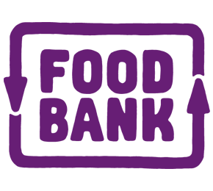
Community Support & Quantin Binnah Community Centre would like to thank our generous partners who have supported us to deliver our 2026 of activities & services


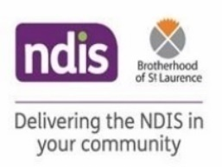




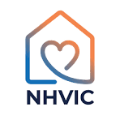

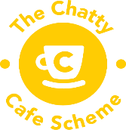

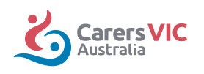


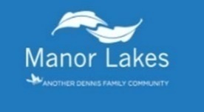






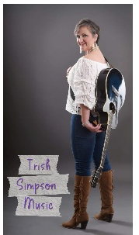










Have a Safe Holiday
Wishing all our families, friends, community members and partners a safe & enjoyable end to 2026 and a happy & healthy start to 2027



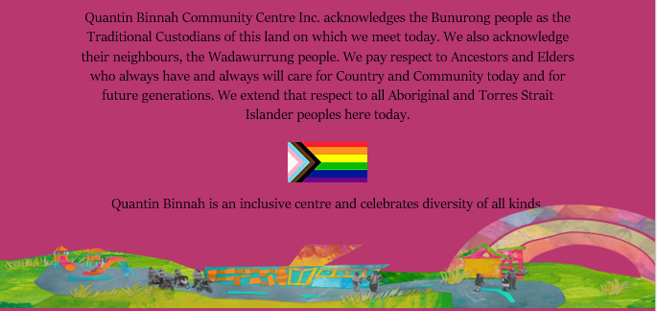

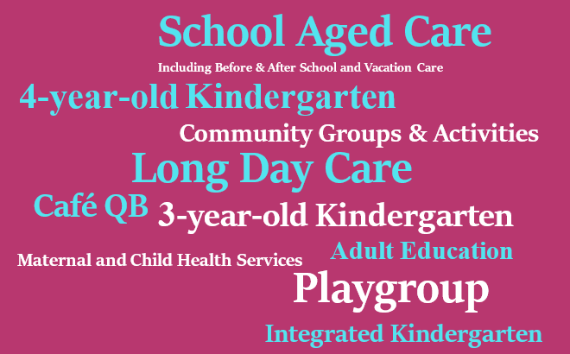

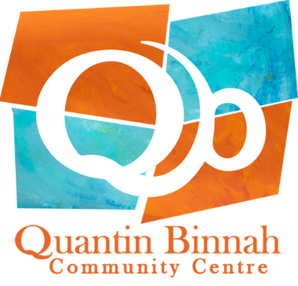

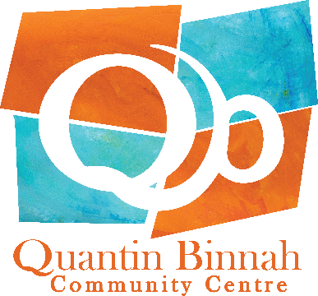
Contact Information







9742 5040
admin@qbcc.org.au
www.qbcc.org.au
www.facebook.com/quantinbinnah

61 Thames Blvd, Werribee
For more information scan our QR code and read our policies here:
Quantin Binnah is a committed Child Safe organisation
and has zero tolerance for child abuse.
Every child and young person accessing Quantin Binnah has the right to feel safe. All Quantin Binnah employees, volunteers, contractors and community representatives have a responsibility to understand and activate their role in preventing, detecting, responding and reporting any suspicions of child abuse to the relevant authorities and maintaining a child-safe culture.

Office Hours:
8:30am to 6:00pm Monday to Friday
Closed on Public Holidays

Our admin office is open
8:30am to 6:00pm Monday to Friday

